**HoleSols**

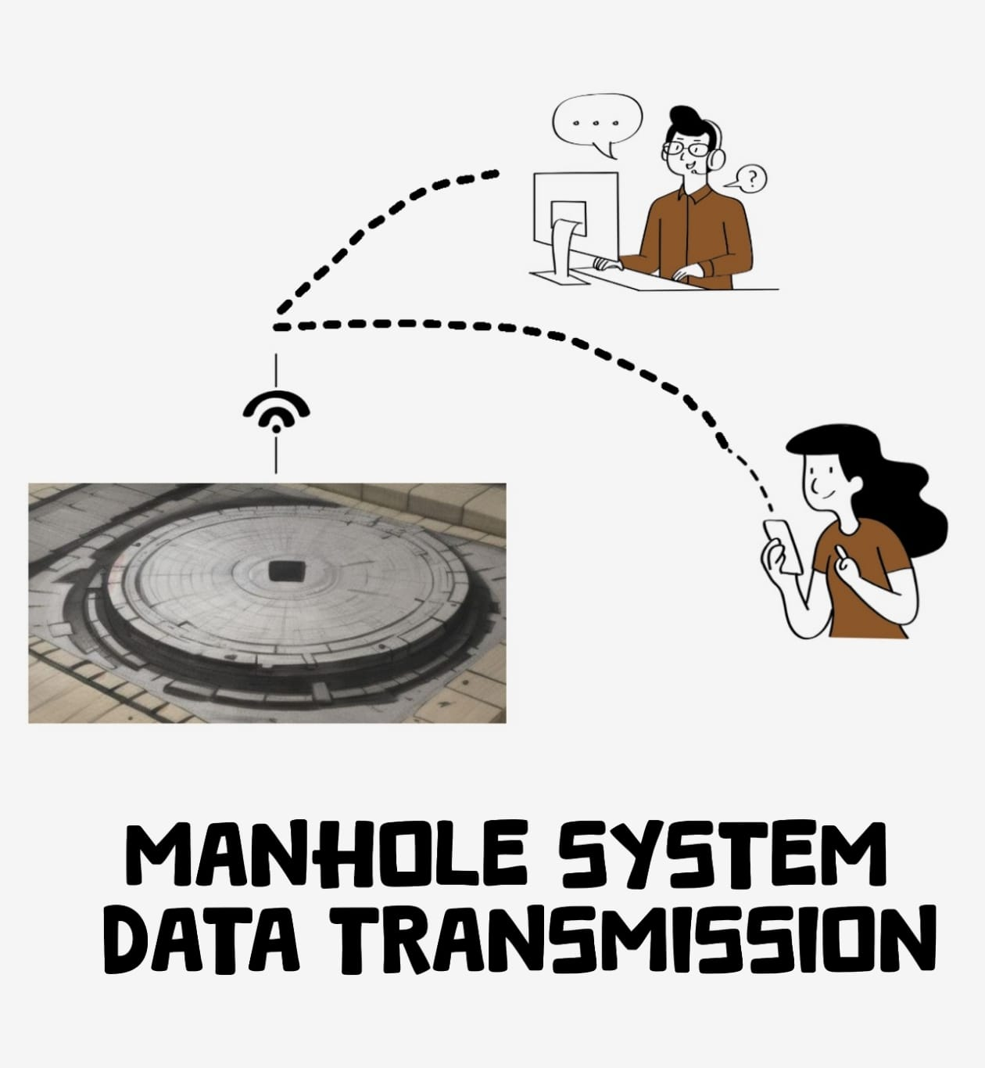 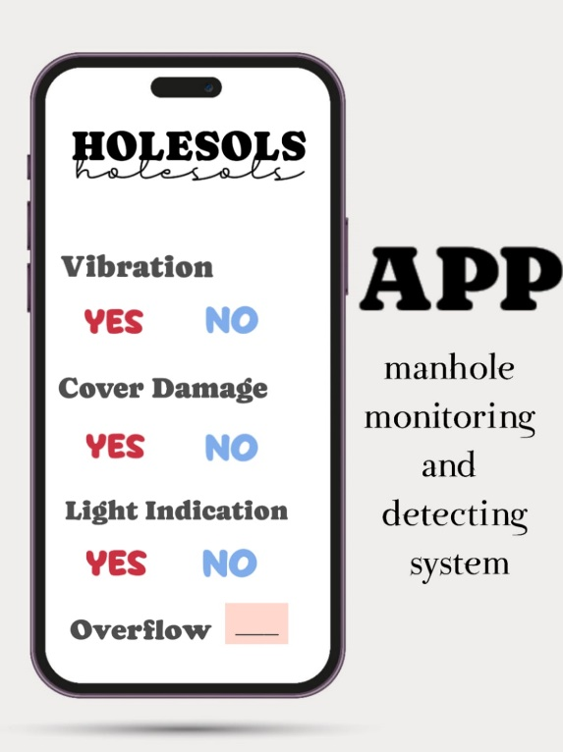

The sensor data from the manhole monitoring and detecting system is collected in real time by the monitoring system. This data is then transmitted through local routers to a central database and the user's app. The app provides alerts for various conditions such as manhole cover damage, vibrations, and water overflow. Additionally, it indicates if the manhole is disrupted through light indicators.